Whole message didn’t fit into one toast, so split it sentence by sentence and show in different Toast

**PROBLEM 1 – Quiz app**

**PROBLEM 2.1 - Shopping categories**

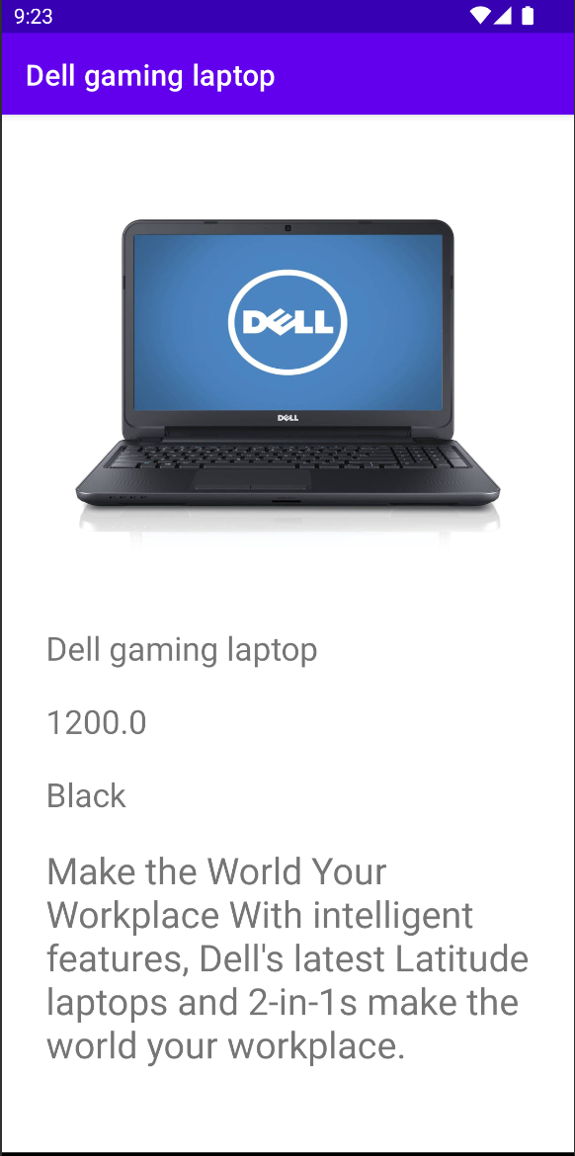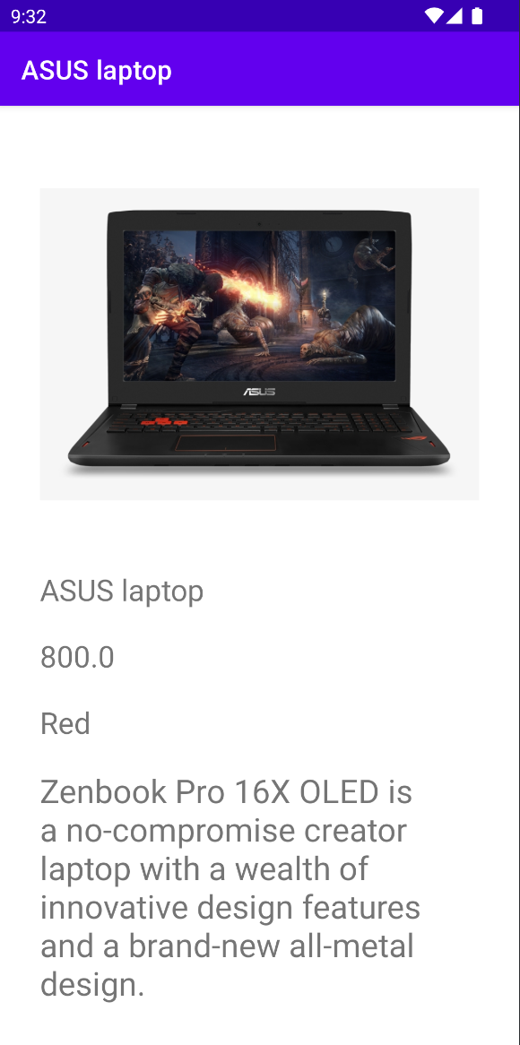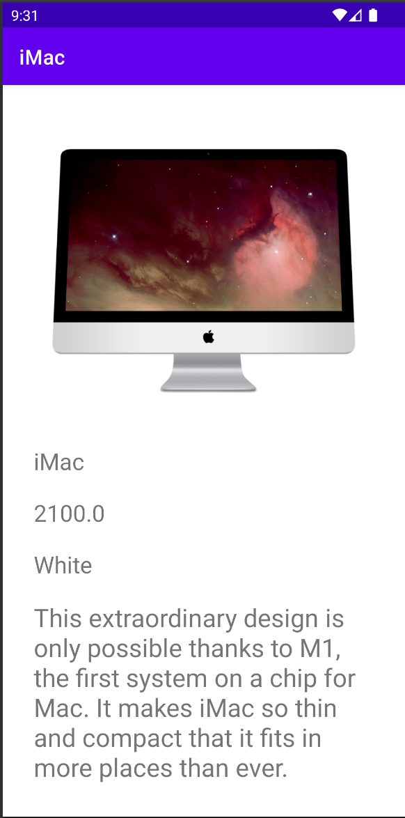

**PROBLEM 2.2 - RecyclerView, Product detail**